
Name: ___________________________ School: ____________________ Date: ________________
Instructions for grades K-2: Who is the kindest person you know from St. Joseph? Write a few sentences about the kindest person you know. State who they are and what they do that is kind. Write your description below and draw a picture in the space provided.

Draw your picture in this space:

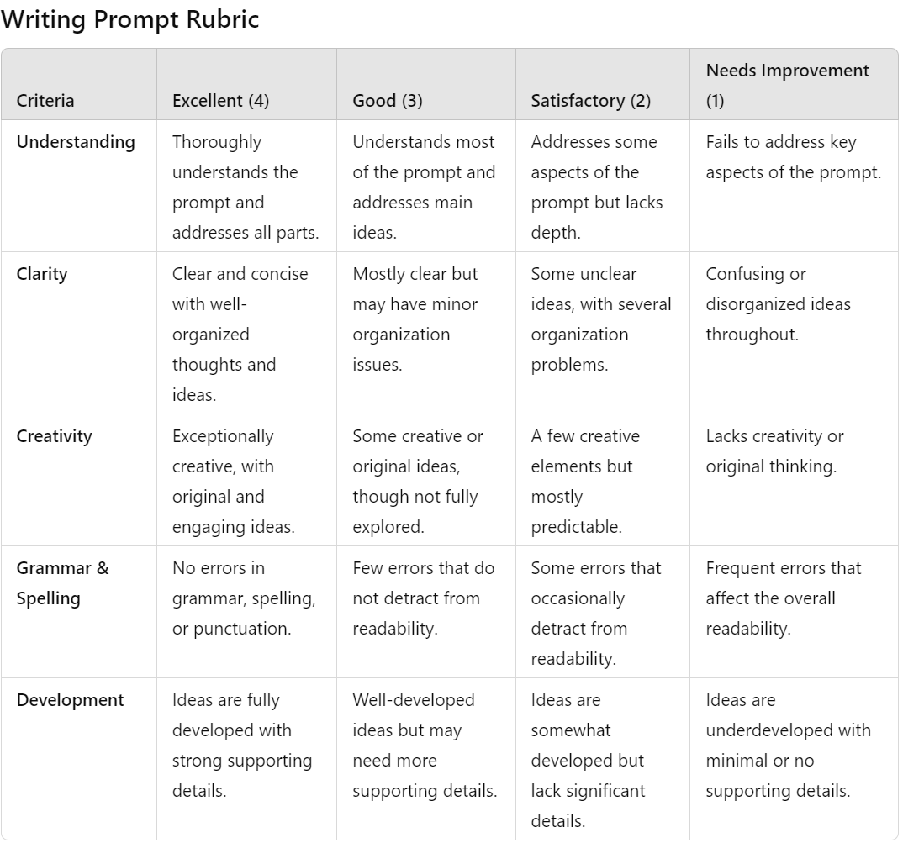

Name: ___________________________ School: ____________________ Date: ________________
Instructions for grades 3-6: Who is the kindest person you know from St. Joseph? Write at least one paragraph about the kindest person you know. State who they are and what they do that is kind. Write your description below. You may choose to draw a picture in the space provided.

Optional - Draw your picture in this space:

Name: ___________________________ School: ____________________ Date: ________________
Instructions for grades 7-12: Who is the kindest person you know from St. Joseph? Describe in detail who they are and what they do that is kind. Give real examples of the person’s acts of kindness. Write your description below.

